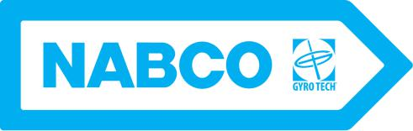

GT600 Fire Door Package Systems

For comprehensive information on door and frame installation, proper smoke detector, etc., the following books are available from the National Fire Protection Association, 470 Atlantic Avenue, Boston, MA 02210

Life Safety Code (NFPA No. 101)

Fire Doors and Windows (NFPA No. 80)

NABCO Entrances, Inc. offers multiple options with regards to having an automatic fire door package. With a fire door assembly, the entire doorway must consist of UL listed equipment. In the event of fire or power failure the doors must close from any position, latch and be able to function as a standard manual emergency exit. The standard fire door package normally includes:

- UL listed door leaf and frame packages. Options exist from several manufacturers.
- UL listed fire exit hardware. Packages approved by UL including the push bars, latch mechanisms, locks and power boxes which are routinely available from manufacturers such as von Duprin, Dorman, Adams Rite and others.
- Standard NABCO Entrances, Inc. activating devices such as the Acusensor, Acumotion, push plates, or other suitable compatible devices.

- Automatic door operator package conversion unit (CU) header with supporting documentation.
- UL specified labels.

For standard installation elevations, sections and other typical information see the drawings for the system GT400 or GT710.

9/17/09

N A B C O E N T R A N C E S I N C . S 8 2 W 1 8 7 1 7 G e m i n i D r i v e M u s k e g o , W I 5 3 1 5 0 Phone: 877-622-2694 Fax: 888-679-3319 Web: www.nabcoentrances.com / www.gyrotech.com

